# Project Planning Phase

**Sprint Delivery plan**

|  |  |
| --- | --- |
| Date | 26 October 2022 |
| Team ID | PNT2022TMID17729 |
| Project Name | Project – Personal Assistance for seniors who are self-reliant |
| Marks | 4 Marks |

**Project Tracker:**

|  |  |  |  |  |  |  |
| --- | --- | --- | --- | --- | --- | --- |
| **Sprint** | **Total Story Point s** | **Duration** | **Sprint Start Date** | **Sprint End Date (Planned)** | **Story Points Completed (as on Planned End Date)** | **Sprint Release Date (Actual)** |
| Sprint-1 | 20 | 6 Days | 24 Oct 2022 | 29 Oct 2022 | 20 | 29 Oct 2022 |
| Sprint-2 | 20 | 6 Days | 31 Oct 2022 | 05 Nov 2022 | 20 | 05 Nov2022 |
| Sprint-3 | 20 | 6 Days | 07 Nov 2022 | 12 Nov 2022 | 20 | 12 Nov 2022 |
| Sprint-4 | 20 | 6 Days | 14 Nov 2022 | 19 Nov 2022 | 20 | 19 Nov 2022 |

**Velocity:**

Sprint duration = 6 days Velocity of the team = 20 points

average velocity (AV) = Velocity

Sprint duration

AV = 20/6 = 3.34

Average Velocity = 3.34

**Burndown Chart:**

A burn down chart is a graphical representation of work left to do versus time. It is often used in agile [software development](https://www.visual-paradigm.com/scrum/what-is-agile-software-development/) methodologies such as [Scrum.](https://www.visual-paradigm.com/scrum/scrum-in-3-minutes/) However, burn down charts can be applied to any project containing measurable progress over time.

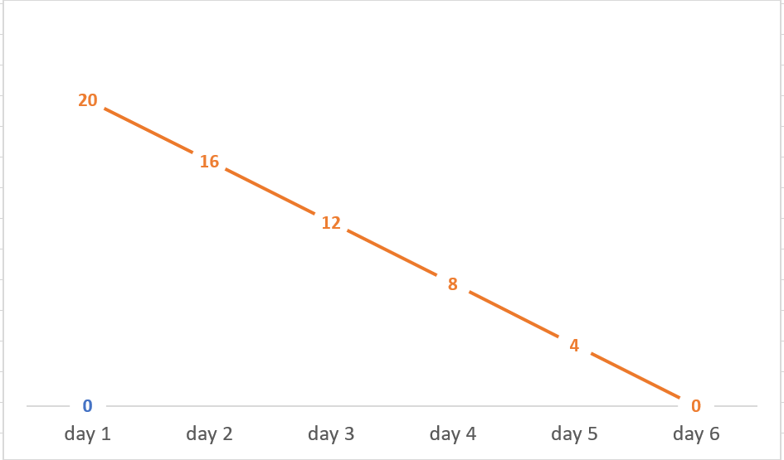

# Sprint duration